Pathway Baptist Church
Severe Weather Operations Plan

Quick Reference Instructions

- Anytime threatening weather is a possibility, ensure someone is monitoring at least one of our weather radios and www.weather.gov/pah on the Security PC in the workroom.

- When a Tornado Warning or Severe Thunderstorm Warning includes Calvert City, ushers (or other leaders for different services) should immediately alert the pastor, or whoever is in the pulpit, by signaling a “T” and/or voicing the warning.

- The person in the pulpit (or other leader/s during different services) will then instruct everyone to follow the ushers to a shelter area.

- In concert with the above action the pre-designated ushers for all other areas of both buildings will go to their assigned location, announce the warning and provide instructions for everyone to immediately halt their activities and follow them to the shelter area.

- Everyone should remain at their sheltered location - with doors completely closed - until the warning has ended or the threat has clearly passed. The all clear will be initiated by the person monitoring weather on the security PC or weather radio.

Overview and Plan Details

The Calvert City area averages a half dozen occurrences of severe thunderstorms each year, in the form of damaging winds, large hail or tornadoes. When either a Watch or Warning is issued for Marshall county each of the 2 weather radios will activate with an audible alert followed by the voice message which provides details about the warning (area covered, storm movement, storm history, expected hazards). One of these weather radios is located in the kitchen (to the right of the sink) of the Ministry Center, with the other located in the Educational –Office Building, in the window of the conference room. These weather radios should be checked periodically to ensure; 1. they have good batteries, 2. are plugged in, and 3. are receiving the signal/ voice broadcast adequately.

Definitions

Severe Thunderstorm - one that produces winds of at least 58 mph, including tornadoes, or hail at least 1 inch in diameter (size of a quarter).

Severe Thunderstorm Watch - Action: Monitor the weather closely. Conditions are favorable for severe thunderstorm. Watches are in effect for several hours and cover large areas (dozens to hundreds of counties).

Severe Thunderstorm Warning - Action: Take Cover Immediately - EVERYONE in our church facilities. Severe weather has been observed (storm spotters, law enforcement etc.) or is imminent (based on radar and other data).

Note: If the threat is more specific to tornadoes, a Tornado Watch, or Tornado Warning is issued, as appropriate.

Flash Flood Watch - Action: Monitor the weather. Conditions are favorable for heavy or excessive rain in a short period of time. These conditions can lead to
a rapid rise in water levels.

Flash Flood Warning - Action: Avoid driving through water covered roads. Move to higher ground if threatened y rising water. Generally the application for our church is simply to announce the warning before church is dismissed so that caution can more readily be exercised when driving home.

Determining if the Warning is for Calvert City

Warning areas for severe thunderstorms, tornadoes and flash floods are "storm based". When a warning alerts on either of our weather radios it will do so for a warning anywhere in Marshall County. As such there will be times when there is no danger to us in Calvert City, therefore no reason to take action. To determine if the storm based warning includes us listen carefully to the warning message on weather radio to see if it specifically says "Calvert City". Another way to determine if the warning is for us is via the Security Monitoring Computer in the workroom of the educational building. Go to the Favorites/Bookmark named “Weather Warnings” (via www.weather.gov/pah). The following page should pop up;

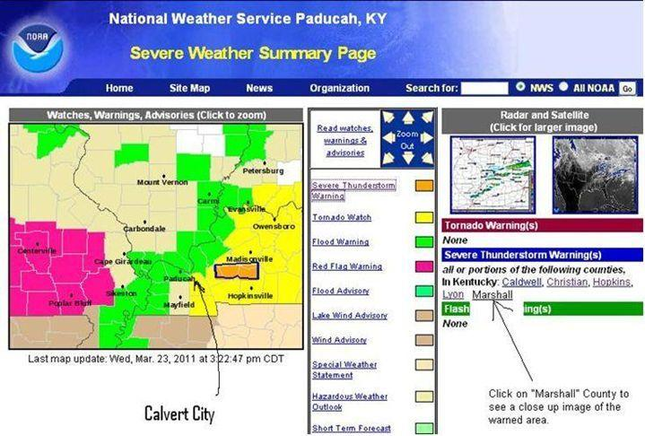

Simply notice if the warning graphic includes northern Marshall (generally at/north of the wording “Paducah” in Marshall County).

Per the sample below, for a zoomed in view of the warning click on “Marshall” under “Tornado Warning(s)” or “Severe Thunderstorm Warning(s)” located on the lower right side of the Severe Weather Summary Page.

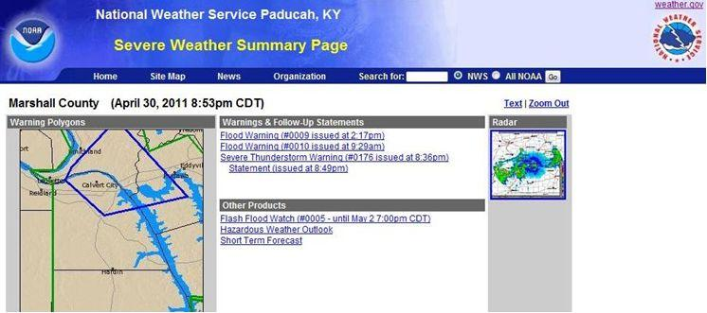

You can also click on the radar image on either of the above pages to see where the storms are located to get a general track of the storm. Caution; tornadoes are generally NOT located within storm cores and the placement varies depending on storm movement and numerous other factors, therefore use the warning announcement or follow up reports for details on tornado location.

Action for a Watch (Tornado, Severe Thunderstorm or Flash Flood)

- The head usher should confer with all ushers to ensure they know what action to take to shelter the congregation should a warning be issued or severe weather threaten. For Sunday mornings this should be done prior to the start of Sunday School or as soon as it is learned a Watch is in effect.
NOTE: For Sunday evening, Wednesday evening and all other times, the pastor, chairman of the deacons, or if not present, any other church leaders (deacons or administrative team members) should briefly discuss the plan for taking shelter if a warning is issued for Calvert City. It is critical that one person be in charge of the overall needed actions.
- The head usher (or designated leader) should ensure someone is appointed to be nearby one of our weather radios at all times during the service.
- The usher (other assigned person) monitoring the PC in the workroom of the Educational-Office building should monitor the “Severe Weather Summary Page” as previously outlined.
- The head usher (or other designee) should have one extra usher/person to help with monitoring the weather, especially to ensure there is no break in monitoring the PC should the primary usher/person have to address other non-weather issues.
- Assignments discussed before/during the Watch phase must incorporate someone being in
charge of going to all occupied areas of BOTH facilities. This will vary
depending on the service (Sunday AM, PM, Wednesday Evening).

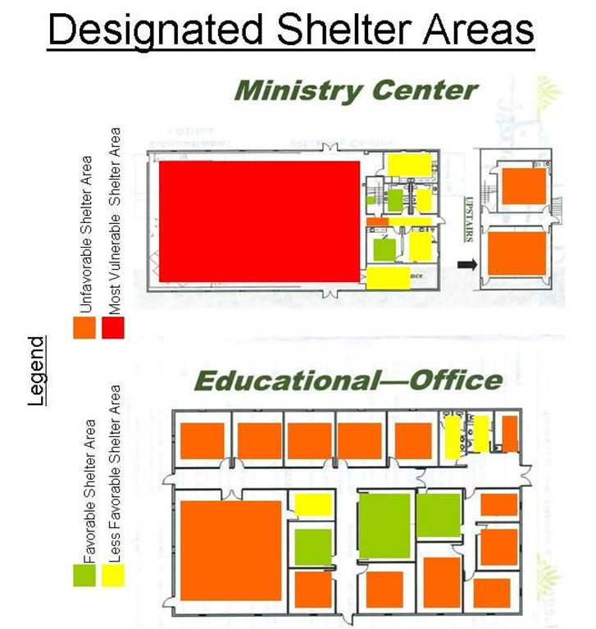

Sunday Morning - Action for a Warning (that includes Calvert City)

Usher Assignments

It is imperative each usher knows who they will lead to the shelter areas and the exact shelter areas they will lead them to. One possibility is to assign the offering ushers on the outside isles to have responsibility for leading people on the outside wings of the congregation to the pre-designated shelter areas. Two other ushers could handle the larger middle wing. The remaining ushers could be divided up for all other groups within our 2 buildings. The head usher should ensure all building occupants have been sheltered.

Usher Actions

- When a Tornado Warning or Severe Thunderstorm Warning includes Calvert City, the head usher or designee should immediately alert the pastor, or whoever is in the pulpit, by signaling a “T” and/or voicing the warning. This should be done immediately.

- The person in the pulpit will then instruct the congregation to follow the ushers to a shelter area. See the maps below for details on usher assignments.

- In concert with the above action the pre-designated ushers for all other areas of both buildings will go to their assigned location, announce the warning and provide instructions for everyone to immediately halt their activities and follow them to the shelter area per the map below.

- If a Warning is issued during the Sunday School hour, the Pastor, Sunday School Director, and available ushers will alert and direct all classrooms in both facilities to the pre-designated shelter areas. Generally the shelter routes and shelter locations will be the same as for a Wednesday evening service.

- Everyone should remain at their sheltered location - with doors completely closed - until the warning has ended or the threat has clearly passed. The all clear will be initiated by the person monitoring weather on the security PC or weather radio.

Notes: Variations in attendance and other factors may necessitate adjustments to sheltering. A primary factor of consideration should be the priority of shelter areas (e.g. favorable areas filled first followed by less favorable etc.)

Sunday Morning – Worship Service - Shelter Routes

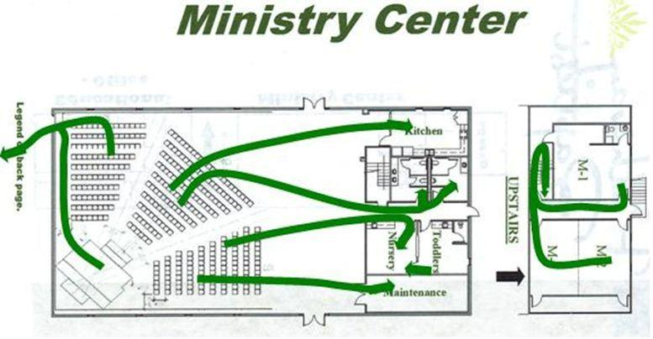

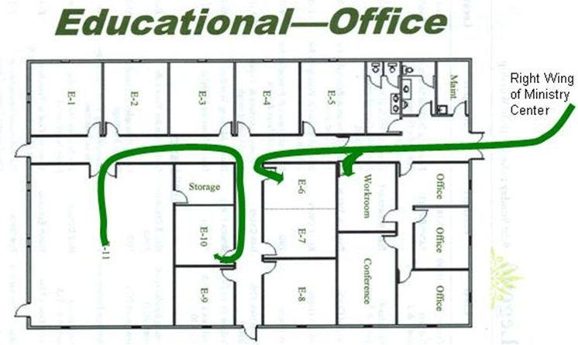

Sunday Evening - Action for a Warning (that includes Calvert City)

- If a Watch is in effect before the service begins, assignments should be made for; 1. having someone monitor weather radios, 2. having someone monitor weather on the Security PC in the workroom, and 3. to direct people at BOTH facilities to pre-designated shelter areas. It may be necessary for this responsibility to be broadened to ushers and deacons on Sunday evening.

- When a Tornado Warning or Severe Thunderstorm Warning includes Calvert City, the head usher or designee should immediately alert the pastor, or whoever is in the pulpit, by signaling a “T” and/or voicing the warning. This should be done immediately.

- The person in the pulpit will then instruct the congregation to follow the ushers to a shelter area. See the maps below for details on usher assignments.

- In concert with the above action the pre-designated ushers for all other areas of both buildings will go to their assigned location, announce the warning and provide instructions for everyone to immediately halt their activities and follow them to the shelter area per the map below.

- Everyone should remain at their sheltered location - with doors completely closed - until the warning has ended or the threat has clearly passed. The all clear will be initiated by the person monitoring weather on the security PC or weather radio.

Sheltering: It is likely that all persons in the Ministry Center can shelter in the pre-designated shelter locations (bathrooms, Crib & Crawlers room, Kitchen and, if necessary, the Maintenance room. Youth and all others in the Educational-Office building should be able to shelter in rooms E-6 and E-7.

Notes: Severe storms, including tornadoes, are about twice as likely during an evening service as during the Sunday AM service.

Variations in attendance and other factors may necessitate adjustments to sheltering. A primary factor of consideration should be the priority of shelter areas (e.g. favorable areas filled first followed by less favorable etc.)

Sunday Evening Service - Shelter Routes

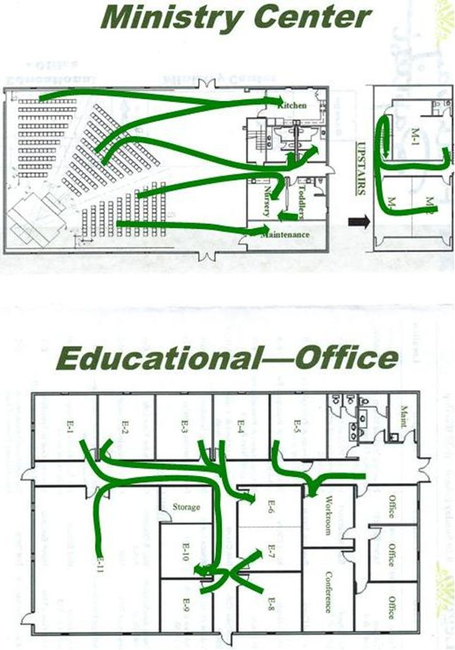

Wednesday Evening - Action for a Warning (that includes Calvert City)

- If a Watch is in effect before AWANA and other events begin, assignments should be made for; 1. having someone monitor weather radios, 2. having someone monitor weather on the Security PC in the workroom, and 3. to direct people at BOTH facilities to pre-designated shelter areas. It may be necessary (if no or few ushers) for this responsibility to be broadened to include deacons or administrative team members in coordination with the AWANA Commander. The pastor (or other church leader in his absence) and AWANA Commander should consider a brief meeting to make assignments and rehearse actions in the event of a Warning.

- When a Tornado Warning or Severe Thunderstorm Warning includes Calvert City, the pre-assigned individuals will immediately notify everyone for their area and lead them to the pre-designated shelter areas per below.

- The pastor or other individual responsible for oversight will verify everyone has taken shelter,
and if not will lead those individuals to shelter.

- Everyone should remain at their sheltered location - with doors completely closed - until the warning has ended or the threat has clearly passed. The all clear will be initiated by the person monitoring weather on the security PC or weather radio.

Sheltering: For AWANA (and most other events), passage between the 2 buildings should be minimized during a Warning, therefore the goal should be to shelter everyone in the building they are in when the warning announcement is made. It is likely that all persons in the Ministry Center can shelter in the pre-designated shelter locations (bathrooms, Crib & Crawlers room, Kitchen and, if necessary, the Maintenance room) within the Ministry Center. AWANA clubbers and workers in the Educational-Office building should be able to shelter in rooms E-6 and E-7. The Youth should shelter in Room E-10 with overflow in the Youth Storage Closet, Workroom, or restrooms.

Notes: Severe storms, including tornadoes, are about twice as likely during an evening service as during the Sunday AM service.

Variations in attendance and other factors may necessitate adjustments to sheltering. A primary factor of consideration should be the priority of shelter areas (e.g. favorable areas filled first followed by less favorable etc.)

Wednesday Evening Service - Shelter Routes

